**Technical aspects**

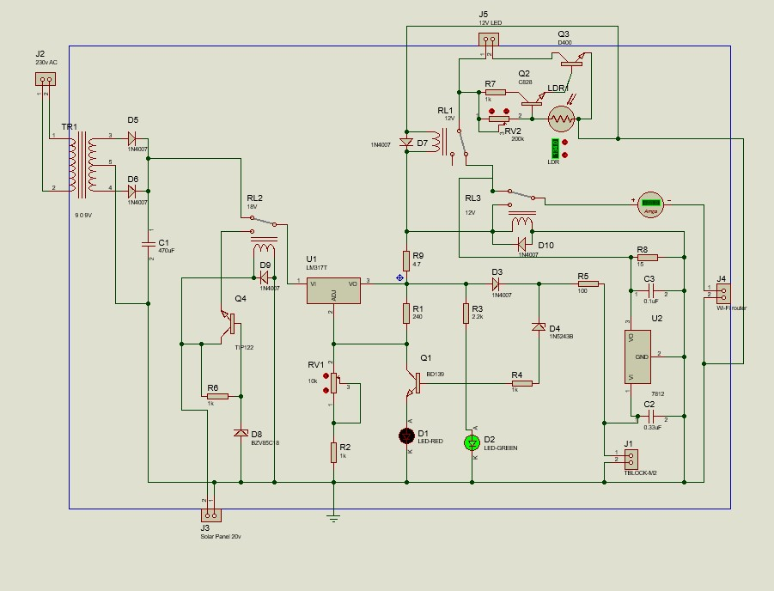

# PRODUCT ARCHITECTURE

AC Power

Supply

Solar Panel

AC / DC

Converter

Simple

Voltage

Regulator

Controller

1

Voltage

Regulator

Voltage

Regulator



Controller



2

Controller

3

Battery

Charger

Battery

## AC/DC converter

9-0-9 V center tapped transformer will step down 230Vac voltage to 18V ac. By using D5, D6 IN4007 diodes, and C1 470uf capacitor, an ac voltage is converted to dc voltage and simply regulated.

Simple solar voltage regulator

TIP122, a resistor, and a Zener diode are used to simply regulate voltage. The resistor R6 provides the necessary biasing for the transistor Q4 to conduct, while the Zener diode D8 value clamps the emitter voltage is controlled at just below the Zener voltage value.

The zener value is therefore appropriately chosen to match the charging voltage of the connected battery. For this circuit, we used a 18v Zener diode and a 20v solar panel.

## Controller 1

During optimal sunshine, the relay gets sufficient power from the panel and remains switched ON with its N/O contacts activated. If the solar panel's output voltage is insufficient, RL2 relay will automatically give power to the circuit using the main current. So this product will work without a solar panel too.

**Voltage regulator**

Since the output of the solar panel is unregulated Dc voltage, LM317T IC (U1) is used to provide regulated DC voltage.

# LM317 T

The LM317T is a positive adjustable voltage regulator designed to supply more than 1.5 A of load current with an output voltage adjustable over a 1.2 to 37 V range. The nominal output voltage is selected by means of only a resistive divider.

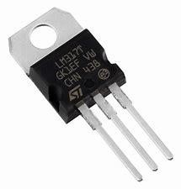

For this circuit input voltage of the LM317T is about 18V and the output voltage is adjusted to 14.8V (since we are using 14.8V battery). pot 10k is used to adjust the output voltage of this voltage regulator LM317.

**Battery Charger**

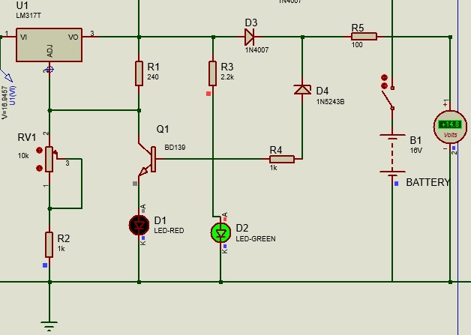 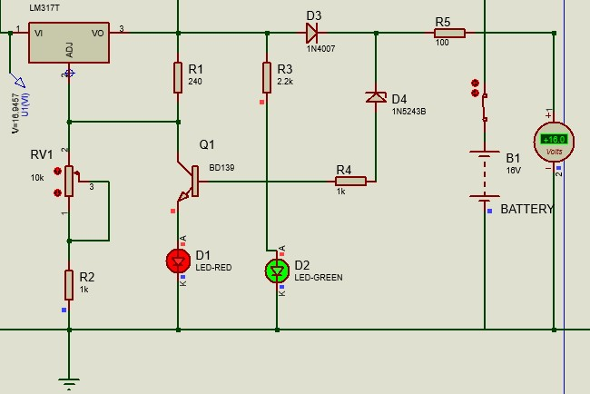

when the battery voltage is below 14.8V, current from LM317 IC flows through the resistor R5 and diode D3 to the battery and the Zener diode will not conduct. green LED is indicating the charge of the battery. Resistor R3 is used to protect the green LED from high voltages.

When the battery voltage rises to 16V, the current flow to the battery stops, and the Zener diode gets sufficient breakdown voltage, and it allows the current through it.

Now the base of the transistor gets sufficient current to turn on and Red LED will turn on. Red LED indicates the full of charge.

Diode D3 is used to avoid the discharge of the battery when the output from the solar panel is very low.

## Battery voltage regulator

Since the output voltage of the battery is unregulated, the 7812 voltage regulator is used to get 12v steady voltage.

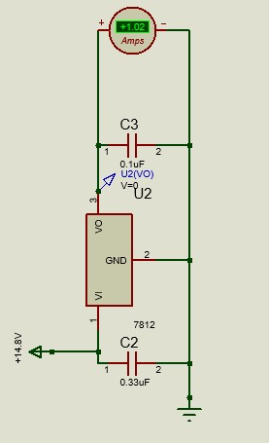

### 7812 voltage regulator

The 7812 is a fixed voltage linear regulator that can output 12V at up to 1A current with an input voltage range of 14 – 35V.

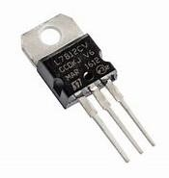

R8 is used to reduce the current from 1A to 0.5A.

# **Controller 2**

When sufficient solar voltage or main current is available Wi-Fi and LED (LED is controlled by RL1) otherwise it will automatically connect to the battery. This operation is controlled by RL3 relay. Since the output voltage of LM317T is 14.8V, R9 4.7 Ohm resistor is used to drop the voltage from 14.8V to 12V.

## Darkness sensitive circuit

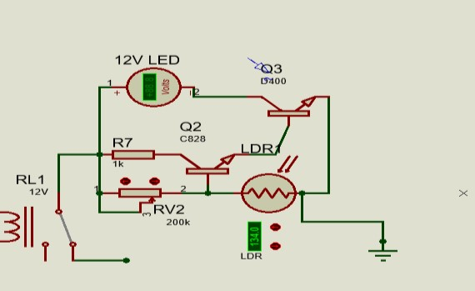

This circuit is used to automatically turn on the LED during power cut times (control by RL1) and in darkness (control by LDR). As mentioned above A-B point will get 12V voltage only in power cut times and LDR resistance is very high in the darkness and LED will be on in dark times. By RV2 variable resistor resistance operating darkness can be changed.